Green Pace Developer: Security Policy Guide



Green Pace Secure Development Policy

Contents
Overview 2
Purpose 2
Scope 2
Module Three Milestone 2
Ten Core Security Principles 2
C/C++ Ten Coding Standards 3
Coding Standard 1 4
Coding Standard 2 5
Coding Standard 3 6
Coding Standard 4 7
Coding Standard 5 8
Coding Standard 6 9
Coding Standard 7 10
Coding Standard 8 11
Coding Standard 9 13
Coding Standard 10 14
Defense-in-Depth Illustration 15
Project One 15
1. Revise the C/C++ Standards 15
2. Risk Assessment 15
3. Automated Detection 15
4. Automation 15
5. Summary of Risk Assessments 16
6. Create Policies for Encryption and Triple A 16
7. Map the Principles 17
Audit Controls and Management 18
Enforcement 18
Exceptions Process 18
Distribution 19
Policy Change Control 19
Policy Version History 19
Appendix A Lookups 19
Approved C/C++ Language Acronyms 19

Overview
Software development at Green Pace requires consistent implementation of secure principles to all developed applications. Consistent approaches and methodologies must be maintained through all policies that are uniformly defined, implemented, governed, and maintained over time.

Purpose
This policy defines the core security principles; C/C++ coding standards; authorization, authentication, and auditing standards; and data encryption standards. This article explains the differences between policy, standards, principles, and practices (guidelines and procedure): Understanding the Hierarchy of Principles, Policies, Standards, Procedures, and Guidelines.

Scope
This document applies to all staff that create, deploy, or support custom software at Green Pace.

Module Three Milestone

Ten Core Security Principles
Principles | Write a short paragraph explaining each of the 10 principles of security.
- Validate Input Data | Any form of input, even input without malicious intent could result in unexpected behavior if not handled properly. Proper coding practices should be utilized to ensure that input from users is reasonably checked in the event that it might allow for unexpected behavior on the system. This includes things like SQL injection protection, authentication verification, and more.
- Heed Compiler Warnings | While warnings won't necessarily always cause breaks or errors in code, it leaves the possibility open for unexpected behavior in certain edge cases. Developers should always strive for clean, code with no errors or warnings, if possible, to avoid these risks.
- Architect and Design for Security Policies | Systems should be designed with all necessary policy considerations in place. Starting from a secure baseline helps ensure systems are protected as soon as they are deployed. This mitigates a lot of day 0 vulnerabilities that might be exploited with simple means.
- Keep It Simple | This concept pertains to the idea that interfacing security mechanisms should be clear and intuitive for users. It should encourage them to use the systems as intended instead of being tempted to try to circumvent the systems in place which would cause security concerns.
- Default Deny | It should be assumed that any form of access requested from a user can be malicious or being performed by someone who is unauthorized to access that information. Systems should always assume the user doesn't have access if there is room for doubt. This could also include mechanisms put in place such as making a user log back in even if they've only been away for a few minutes.
- Adhere to the Principle of Least Privilege | Account access permissions for a user should be restricted to only what is necessary for that user. If a user type does not or should not be able to access certain API calls, for example, then proper safeguards should be put in place to prevent them from making calls to those APIs.
- Sanitize Data Sent to Other Systems | Even though data might be harmless on your own system, it should not be assumed that it would be harmless on another as it may be interpreted differently if not handled carefully. Removing escape characters, converting to safe/standard data types, and only sending what is necessary are some basic considerations in these cases.
- Practice Defense in Depth | The principle behind this concept is that having more layers decreases the likelihood of a successful breach. This could mean things like authentication systems, coding practices, or even physical security concepts. If attackers must unlock multiple doors to get into the system, it is more likely to detect those potential threats and stop them before they become a legitimate issue.
- Use Effective Quality Assurance Techniques | Before code changes are put into a production environment, they should ideally spend time with a team of testers who can rigorously evaluate the security or stability impacts that the code might have. This could mean things such as unit tests, testing edge cases, or simply performing unexpected behavior while operating the system. Only once a reasonable check has been performed should the code be allowed to be published.
- Adopt a Secure Coding Standard | Having all the developers on the same page of understanding helps prevent issues that would occur because of oversights in coding considerations from occurring. This could mean things such as having all developers regularly have their code static tested or have regular intervals of reformatting code to ensure it is clear and concise. It could also mean making sure there is a standard of approach in similar branches of logic or considerations for handling data among other things.

C/C++ Ten Coding Standards
Complete the coding standards portion of the template according to the Module Three milestone requirements. In Project One, follow the instructions to add a layer of security to the existing coding standards. Please start each standard on a new page, as they may take up more than one page. The first seven coding standards are labeled by category. The last three are blank so you may choose three additional standards. Be sure to label them by category and give them a sequential number for that category. Add compliant and noncompliant sections as needed to each coding standard.

Coding Standard 1

Coding Standard | Label | Name of Standard
Data Type | [STD-001-CPP] | Selecting the correct data type prevents data truncation, overflow, and unintended behavior. Using fixed-width or appropriate types ensures predictable results and improves portability across systems.

Noncompliant Code
This example uses an incorrect type that may cause overflow when storing larger values.
int smallValue = 123456789;

Compliant Code
This example uses a larger data type capable of safely storing the value.
long long largeValue = 123456789;

Note: Stop here for the milestone. Complete this section for Project One in Module Six.
Principles(s):
- Principle 6 (Least Privilege): Using appropriate data types limits unintended access or misuse of memory.
- Principle 5 (Keep It Simple): Simpler and correct data types reduce logic errors and vulnerabilities.

Threat Level
Severity | Likelihood | Remediation Cost | Priority | Level
High | Likely | Medium | High | 2

Automation
Tool | Version | Checker | Description Tool
Clang-Tidy | 15+ | Cert-int | Detects incorrect integer usage and type issues
SonarQube | 9.x | S5276 | Identifies unsafe type conversions
CppCheck | 2.x | typeMismatch | Detects type-related issues

Coding Standard 2

Coding Standard | Label | Name of Standard
Data Value | [STD-002-CPP] | Unvalidated input may lead to vulnerabilities such as crashes, logic errors, or security exploits. Proper validation ensures that values fall within acceptable ranges.

Noncompliant Code
The program accepts user input without validating its range.
int age;
std::cin >> age;

Compliant Code
This version validates the user input before using it.
int age;
std::cin >> age;
if(age >= 0 && age <= 120){
std::cout << "Valid age";}
else{
std::cout << "Invalid input";}

Note: Stop here for the milestone. Complete this section for Project One in Module Six.
Principles(s):
- Principle 1 (Validate Input Data): Ensures all values are checked before use
- Principle 5 (Default Deny): Rejects invalid or unexpected input

Threat Level
Severity | Likelihood | Remediation Cost | Priority | Level
SonarQube | Likely | Low | High | 1

Automation
Tool | Version | Checker | Description Tool
SonarQube | 9.x | S2583 | Detects improper validation
Clang-Tidy | 15+ | cert-err34-c | Detects improper input handling
Cppcheck | 2.x | invalidInput | Identifies missing validation

Coding Standard 3

Coding Standard | Label | Name of Standard
String Correctness | [STD-003-CPP] | Improper string handling can lead to buffer overflow vulnerabilities. Developers should use safe string functions and avoid fixed-size buffers when possible.

Noncompliant Code
This code copies a string without checking its size.
char buffer[10];
strcpy(buffer, "This string is too long");

Compliant Code
This example limits the copied characters to prevent overflow.
char buffer[10];
strncpy(buffer, "SafeText", sizeof(buffer)-1);
buffer[sizeof(buffer)-1] = '\0';

Note: Stop here for the milestone. Complete this section for Project One in Module Six.
Principles(s):
- Principle 8 (Defense in Depth): Prevents exploitation through layered protections
- Principle 4 (Keep It Simple): Safer string handling reduces complexity

Threat Level
Severity | Likelihood | Remediation Cost | Priority | Level
Critical | Likely | Medium | Critical | 1

Automation
Tool | Version | Checker | Description Tool
Cppcheck | 2.x | bufferOverflow | Detects unsafe string usage
Clang-Tidy | 15+ | cert-str34-c | Detects unsafe string copying
AddressSanitizer | GCC/Clang | runtime | Detects buffer overflows

Coding Standard 4

Coding Standard | Label | Name of Standard
SQL Injection | [STD-004-CPP] | SQL injection occurs when untrusted input is inserted directly into a database query. Parameterized queries prevent attackers from modifying the intended query structure.

Noncompliant Code
User input is directly concatenated into the SQL query.
std::string query = "SELECT * FROM users WHERE name = '" + username + "'";

Compliant Code
Prepared statements prevent SQL injection attacks.
sqlite3_prepare_v2(db, "SELECT * FROM users WHERE name = ?", -1, &stmt, NULL);
sqlite3_bind_text(stmt, 1, username.c_str(), -1, SQLITE_STATIC);

Note: Stop here for the milestone. Complete this section for Project One in Module Six.
Principles(s):
- Principle 1 (Validate Input Data): Prevents malicious input
- Principle 8 (Defense in Depth): Adds query-level protections

Threat Level
Severity | Likelihood | Remediation Cost | Priority | Level
Critical | Likely | Medium | Critical | 1

Automation
Tool | Version | Checker | Description Tool
SonarQube | 9.x | S3649 | Detects injection vulnerabilities
Semgrep | latest | sql-injection | Detects unsafe SQL patterns
Clang Static Analyzer | latest | taint analysis | Tracks unsafe input flow

Coding Standard 5

Coding Standard | Label | Name of Standard
Memory Protection | [STD-005-CPP] | Failing to release allocated memory can cause resource exhaustion and instability. Proper memory management ensures reliability and security.

Noncompliant Code
Memory is allocated but never freed.
int* numbers = new int[100];

Compliant Code
Memory is released after use.
int* numbers = new int[100];
delete[] numbers;

Note: Stop here for the milestone. Complete this section for Project One in Module Six.
Principles(s):
- Principle 8 (Defense in Depth): Protects memory at multiple layers
- Principle 6 (Least Privilege): Limits access to memory regions

Threat Level
Severity | Likelihood | Remediation Cost | Priority | Level
High | Likely | Medium | High | 2

Automation
Tool | Version | Checker | Description Tool
Valgrind | latest | memcheck | Detects leaks and misuse
AddressSanitizer | GCC/Clang | runtime | Detects memory errors
Cppcheck | 2.x | memleak | Identifies potential memory leaks

Coding Standard 6

Coding Standard | Label | Name of Standard
Assertions | [STD-006-CPP] | Assertions help detect programming errors early by verifying assumptions during development and testing.

Noncompliant Code
The function assumes the pointer is valid without checking.
void printValue(int* ptr){
std::cout << *ptr;
}

Compliant Code
An assertion verifies that the pointer is valid.
#include <cassert>

void printValue(int* ptr){
assert(ptr != nullptr);
std::cout << *ptr;
}

Note: Stop here for the milestone. Complete this section for Project One in Module Six.
Principles(s):
- Principle 3 (Fail Securely): Ensures safe failure
- Principle 4 (Keep It Simple): Improves debugging clarity

Threat Level
Severity | Likelihood | Remediation Cost | Priority | Level
Medium | Possible | Low | Medium | 3

Automation
Tool | Version | Checker | Description Tool
Clang-Tidy | 15+ | cert-dcl03-c | Detects missing assertions within code
SonarQube | 9.x | S5960 | Detects weak assumptions within code
Cppcheck | 2.x | nullPointer | Detects unsafe dereferences in code

Coding Standard 7

Coding Standard | Label | Name of Standard
Exceptions | [STD-007-CPP] | Exception handling allows programs to gracefully recover from unexpected errors instead of crashing.

Noncompliant Code
The program does not handle potential runtime errors.
int result = 10 / divisor;

Compliant Code
Exceptions are used to manage potential errors.
try{
if(divisor == 0){
throw std::runtime_error("Division by zero");
}
int result = 10 / divisor;
}
catch(const std::exception& e){
std::cout << e.what();
}

Note: Stop here for the milestone. Complete this section for Project One in Module Six.
Principles(s):
- Principle 3 (Fail Securely): Handles runtime errors safely
- Principle 2 (Architect Securely): Ensures structured error handling

Threat Level
Severity | Likelihood | Remediation Cost | Priority | Level
High | Possible | Medium | High | 2

Automation
Tool | Version | Checker | Description Tool
Clang-Tidy | 15+ | cert-err60-c | Detects improper exception handling
SonarQube | 9.x | S2738 | Detects unhandled exceptions
Cppcheck | 2.x | exceptionSafety | Identifies missing try/catch

Coding Standard 8

Coding Standard | Label | Name of Standard
Input Validation | [STD-008-CPP] | External inputs are common entry points for attacks. Validating inputs prevents malicious data from affecting system operations.

Noncompliant Code
Does not validate input.
std::string filename;
std::cin >> filename;
openFile(filename);

Compliant Code
Correctly validates input.
std::string filename;
std::cin >> filename;
if(filename.find("..") == std::string::npos){
openFile(filename);
}

Note: Stop here for the milestone. Complete this section for Project One in Module Six.
Principles(s):
- Principle 1 (Validate Input Data): Prevents malicious input
- Principle 5 (Default Deny): Rejects invalid or unexpected input

Threat Level
Severity | Likelihood | Remediation Cost | Priority | Level
Critical | Likely | Low | Critical | 1

Automation
Tool | Version | Checker | Description Tool
SonarQube | 9.x | S5131 | Detects unvalidated input
Semgrep | latest | input-validation | Detects unsafe input
Cppcheck | 2.x | invalidInput | Flags missing validation checks made for input

Coding Standard 9

Coding Standard | Label | Name of Standard
Integer Overflow | [STD-009-CPP] | Integer overflow can cause incorrect calculations and security vulnerabilities. Programs must verify numeric operations before execution.

Noncompliant Code
Does not check for integer overflow.
int result = a + b;

Compliant Code
Ensures integer overflow is checked and correctly detected.
if(a > INT_MAX - b){
std::cout << "Overflow detected";}
else{
int result = a + b;}

Note: Stop here for the milestone. Complete this section for Project One in Module Six.
Principles(s):
- Principle 6 (Least Privilege): Using appropriate data types helps prevent miscalculations
- Principle 4 (Keep It Simple)

Threat Level
Severity | Likelihood | Remediation Cost | Priority | Level
High | Possible | Medium | High | 2

Automation
Tool | Version | Checker | Description Tool
Clang-Tidy | 15+ | cert-int32-c | Detects overflow issues
UBSan | GCC/Clang | runtime | Detects integer overflow
Cppcheck | 2.x | integerOverflow | Flags overflow risks

Coding Standard 10

Coding Standard | Label | Name of Standard
Resource Management | [STD-010-CPP] | Resource Acquisition Is Initialization (RAII) ensures that resources are automatically released when objects go out of scope, preventing leaks.

Noncompliant Code
Does not release resources.
FILE* file = fopen("data.txt","r");

Compliant Code
Correctly releases resources.
#include <fstream>
std::ifstream file("data.txt");

Note: Stop here for the milestone. Complete this section for Project One in Module Six.
Principles(s):
- Principle 8 (Defense in Depth): ensure that even if other safeguards fail, the program remains stable and secure
- Principle 4 (Keep It Simple): reduces manual cleanup code and minimizing complexity and potential errors

Threat Level
Severity | Likelihood | Remediation Cost | Priority | Level
Medium | Possible | Low | Medium | 3

Automation
Tool | Version | Checker | Description Tool
Cppcheck | 2.x | resourceLeak | Detects potential resource leaks
Valgrind | latest | memcheck | Tracks resource usage to catch potential leaks/improper memory releasing practices
Clang-Tidy | 15+ | cert-dcl54-cpp | Enforces RAII

Defense-in-Depth Illustration
This illustration provides a visual representation of the defense-in-depth best practice of layered security.

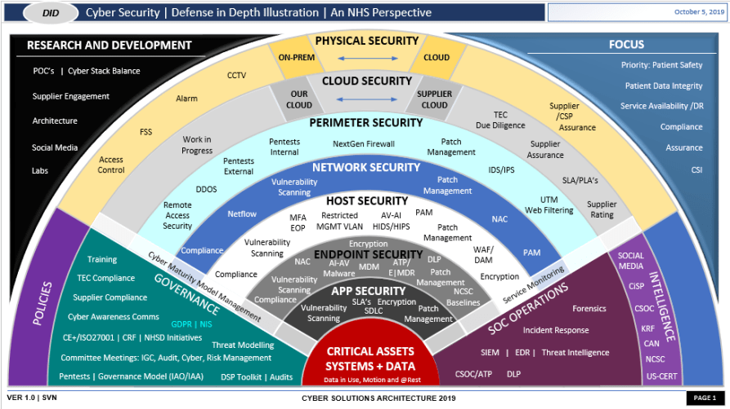

Project One
There are seven steps outlined below that align with the elements you will be graded on in the accompanying rubric. When you complete these steps, you will have finished the security policy.

Revise the C/C++ Standards
You completed one of these tables for each of your standards in the Module Three milestone. In Project One, add revisions to improve the explanation and examples as needed. Add rows to accommodate additional examples of compliant and noncompliant code. Coding standards begin on the security policy.

Risk Assessment
Complete this section on the coding standards tables. Enter high, medium, or low for each of the headers, then rate it overall using a scale from 1 to 5, 5 being the greatest threat. You will address each of the seven policy standards. Fill in the columns of severity, likelihood, remediation cost, priority, and level using the values provided in the appendix.

Automated Detection
Complete this section of each table on the coding standards to show the tools that may be used to detect issues. Provide the tool name, version, checker, and description. List one or more tools that can automatically detect this issue and its version number, name of the rule or check (preferably with link), and any relevant comments or description—if any. This table ties to a specific C++ coding standard.

Automation
Provide a written explanation using the image provided.
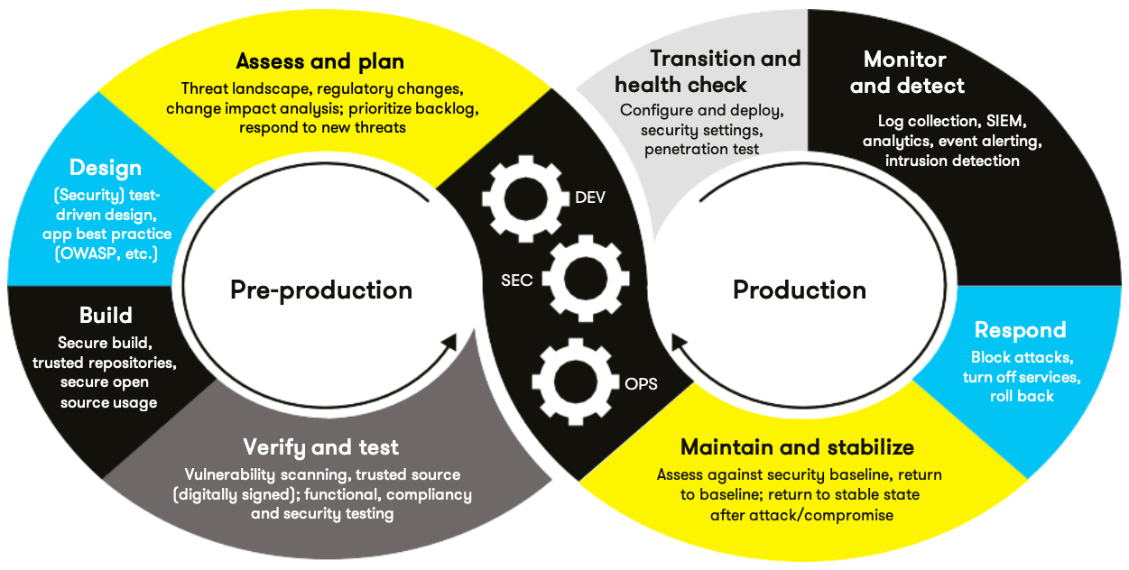

Automation will be used for the enforcement of 11 and compliance to the standards defined in this policy. Green Pace already has a well-established DevOps process and infrastructure. Define guidance on where and how to modify the existing DevOps process to automate enforcement of the standards in this policy. Use the DevSecOps diagram and provide an explanation using that diagram as context.

Various tools have been identified in the previous sections that will facilitate an effective DevSecOps implementation. During both pre-production and production, developers
will begin with assessing and planning, where potential risks and requirements are identified. It will then move into designing and building, where developers will use IDE-integrated tools like Clang-Tidy to catch issues early as they write code. Before code is committed, lightweight tools such as Cppcheck will run to prevent insecure code from entering the repository. At the center of this loop, DevSecOps will ensure that security remains integrated throughout the process. As development progresses into continuous integration, tools like SonarQube will perform comprehensive scans and enforce quality gates, stopping builds if critical vulnerabilities are found. During testing, dynamic analysis tools such as Valgrind and AddressSanitizer will be used to detect runtime issues like memory leaks and buffer overflows. The cycle will then continue with monitoring and improvement, allowing the system to be continuously refined and strengthened, reinforcing a defense-in-depth approach to security.

Summary of Risk Assessments
Consolidate all risk assessments into one table including both coding and systems standards, ordered by standard number.

Rule | Severity | Likelihood | Remediation Cost | Priority | Level
STD-001-CPP | High | Unlikely | Medium | High | 2
STD-002-CPP | High | Likely | Low | High | 1
STD-003-CPP | Critical | Likely | Medium | Critical | 1
STD-004-CPP | Critical | Likely | Medium | Critical | 1
STD-005-CPP | High | Likely | Medium | High | 2
STD-006-CPP | Medium | Possible | Low | Medium | 3
STD-007-CPP | High | Possible | Medium | High | 2
STD-008-CPP | Critical | Likely | Low | Critical | 1
STD-009-CPP | High | Possible | Medium | High | 2
STD-010-CPP | Medium | Possible | Low | Medium | 3

Create Policies for Encryption and Triple A
Include all three types of encryption (in flight, at rest, and in use) and each of the three elements of the Triple-A framework using the tables provided.
  - Explain each type of encryption, how it is used, and why and when the policy applies.
  - Explain each type of Triple-A framework strategy, how it is used, and why and when the policy applies.

Write policies for each and explain what it is, how it should be applied in practice, and why it should be used.

- Encryption | Explain what it is and how and why the policy applies.
Encryption at rest | Encryption at rest keeps stored data secure by using strong encryption methods like AES-256. The data remains protected even if someone gains unauthorized access to the storage system. This applies to both physical devices and cloud environments, helping ensure sensitive information isn’t exposed in the event of a breach.
Encryption in flight | Encryption in flight protects data as it is being transferred. Using secure protocols like TLS prevents anyone from intercepting or tampering with the data while it’s being transmitted between systems or users. Essentially, it keeps data secure while it’s being communicated.
Encryption in use | Encryption in use focuses on protecting data while it’s actively being processed in memory. Technologies like secure enclaves and memory protection help keep sensitive information safe even during runtime. This is especially important when handling highly sensitive data that needs to be accessed and used securely.

- Triple-A Framework* | Explain what it is and how and why the policy applies.
Authentication | Authentication confirms that users are who they say they are before granting access to the system or its resources. This can include methods like passwords combined with multi-factor authentication. It applies to all entry points into the system, helping prevent unauthorized access from the start.
Authorization | Authorization determines what a user is allowed to do. By using role-based access control, users are only given access to the information and actions necessary for their role.
Accounting | Accounting keeps track of what users do within the system. This includes keeping a log of activities like logins, file access, and database changes. These records provide visibility, support auditing, and help detect and respond to potential security incidents.

*Use this checklist for the Triple A to be sure you include these elements in your policy:

- User logins
- Changes to the database
- Addition of new users
- User level of access
- Files accessed by users

Map the Principles
Map the principles to each of the standards, and provide a justification for the connection between the two. In the Module Three milestone, you added definitions for each of the 10 principles provided. Now it’s time to connect the standards to principles to show how they are supported by principles. You may have more than one principle for each standard, and the principles may be used more than once. Principles are numbered 1 through 10. You will list the number or numbers that apply to each standard, then explain how each of these principles supports the standard. This exercise demonstrates that you have based your security policy on widely accepted principles. Linking principles to standards is a best practice.

NOTE: Green Pace has already successfully implemented the following:

- Operating system logs
- Firewall logs
- Anti-malware logs
The only item you must complete beyond this point is the Policy Version History table.

Audit Controls and Management
Every software development effort must be able to provide evidence of compliance for each software deployed into any Green Pace managed environment.

Evidence will include the following:

- Code compliance to standards
- Well-documented access-control strategies, with sampled evidence of compliance
- Well-documented data-control standards defining the expected security posture of data at rest, in flight, and in use
- Historical evidence of sustained practice (emails, logs, audits, meeting notes)

Enforcement
The office of the chief information security officer (OCISO) will enforce awareness and compliance of this policy, producing reports for the risk management committee (RMC) to review monthly. Every system deployed in any environment operated by Green Pace is expected to be in compliance with this policy at all times.

Staff members, consultants, or employees found in violation of this policy will be subject to disciplinary action, up to and including termination.

Exceptions Process
Any exception to the standards in this policy must be requested in writing with the following information:

- Business or technical rationale
- Risk impact analysis
- Risk mitigation analysis
- Plan to come into compliance
- Date for when the plan to come into compliance will be completed

Approval for any exception must be granted by chief information officer (CIO) and the chief information security officer (CISO) or their appointed delegates of officer level.

Exceptions will remain on file with the office of the CISO, which will administer and govern compliance.

Distribution
This policy is to be distributed to all Green Pace IT staff annually. All IT staff will need to certify acceptance and awareness of this policy annually.

Policy Change Control
This policy will be automatically reviewed annually, no later than 365 days from the last revision date. Further, it will be reviewed in response to regulatory or compliance changes, and on demand as determined by the OCISO.

Policy Version History

Version | Date | Description | Edited By | Approved By
1.0 | 08/05/2020 | Initial Template | David Buksbaum
2.0 | 03/22/2026 | Milestone | Summer Stinnett
3.0 | 04/12/2026 | Project | Summer Stinnett

Appendix A Lookups

Approved C/C++ Language Acronyms

Language | Acronym
C++ | CPP
C | CLG
Java | JAV

